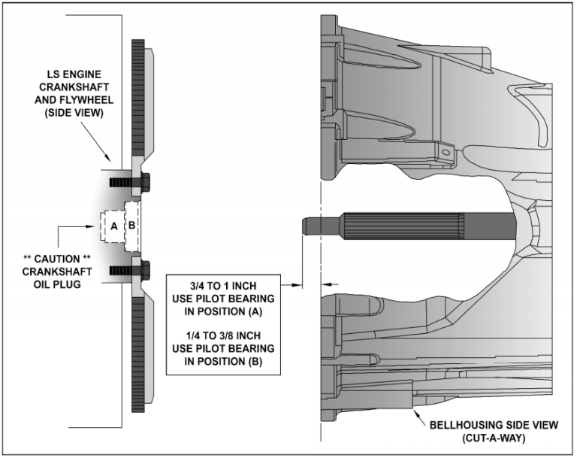
Pilot bearing for crankshaft position “A” is a SMALL outside diameter (1.094”) GM pilot bearing that fits into the innermost pocket of the crankshaft flange. This bearing is typically (but NOT ALWAYS) used with Transmission/Bell housings on GM; LS1 powered vehicles from 1998 to 2002. NOTE: if using the small GM pilot bearing, the internal O-ring seal faces the transmission when installed properly.
Pilot bearing for crankshaft position “B” is a MEDIUM outside diameter (1.652”) GM pilot bearing that fits into the outer pocket of the crankshaft flange. This bearing is typically (but NOT ALWAYS) used with Transmission/Bell housings on GM; LS3, LSA, LSX and LS9 powered vehicles from 2003 to 2012. NOTE: This is a double sealed bearing and it may be installed either direction into the crankshaft.
Oversize Pilot bearing for crankshaft position “B” is a LARGER outside diameter (1.705”) GM pilot bearing that fits into the outer pocket of the crankshaft flange. This bearing can be used with SOME aftermarket crankshafts and/or GM CRATE engines where the crankshaft pilot bearing bore is oversized AND you are using a Transmission/Bell housing combination from a 2003 to 2012 GM vehicle. NOTE: This is a double sealed bearing and it may be installed either direction into the crankshaft.
In most cases, you can dimensionally match the old pilot bearing to one of the new pilot bearings. IMPORTANT NOTE: many GM LS engines use a press-in oil plug deep inside the crankshaft flange. DO NOT move or disturb this plug when removing or installing a pilot bearing. Your old pilot bearing must be removed by means of a mechanical pilot bearing puller. DO NOT attempt to use a “hydraulic” method to push-out or remove your old pilot bearing!
The best method to determine the correct pilot bearing position for your application is by using a straight edge or yard stick across the front of your transmission Bell housing and measure the distance that your transmission input shaft protrudes past the front of the bell housing.
If your transmission input shaft dimension is between 3/4 to 1 inch (19mm to 25.4mm) use the SMALL diameter pilot bearing in crankshaft position (A).
If your transmission input shaft dimension is between 1/4 to 3/8 inch (6.3mm to 9.5mm) test fit the MEDIUM outside diameter pilot bearing into crankshaft position (B). The pilot bearing should be a slight press fit into the crankshaft. If the MEDIUM diameter bearing is a loose fit, please use the LARGE outside diameter bearing for a slight press fit into the crankshaft.

